**Best Shopify Development Company in Noida**

RS Organisation is recognized as the best **Shopify Development Company in Noida**, offering tailored Shopify solutions that drive e-commerce success. We help businesses launch, scale, and optimize online stores with advanced features and seamless user experiences. Choose our expert team to elevate your e-commerce presence today.

**Why Choose Shopify For Website Development?**

Shopify is a powerful and flexible platform designed specifically for e-commerce. It allows you to build scalable, secure, and user-friendly online stores without the need for deep technical expertise. Its built-in features, extensive app ecosystem, and mobile responsiveness make it a top choice for businesses of all sizes.

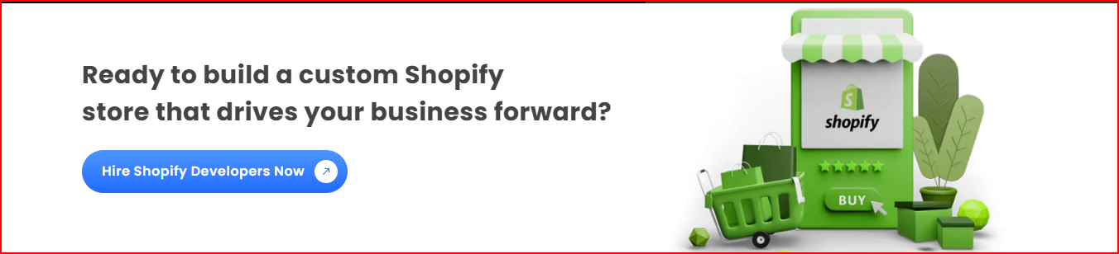

**Custom Shopify Development Services Offered By Us**

**1. Shopify Consulting**  
Our Shopify consulting services offer expert guidance in choosing the right Shopify solutions for your e-commerce store. We analyze your business goals and provide tailored strategies to optimize your store’s performance, increase conversions, and improve user experience on the Shopify platform.

**2. Shopify Third-Party Integration**  
We provide seamless integration of third-party apps and tools to enhance your store’s functionality. Whether it's payment gateways, CRM, inventory systems, or analytics tools, our Shopify Development Company in Noida ensures every integration works efficiently with your store.

**3. Shopify Dropshipping**  
RS Organisation specializes in setting up Shopify dropshipping stores that are easy to manage and scalable. From product sourcing to backend automation, we handle all aspects to help you launch a profitable dropshipping business with minimal overhead and maximum efficiency.

**4. Shopify Migration**  
Want to move your store to Shopify? Our migration services ensure zero data loss and minimal downtime. We handle every detail from data transfer to SEO preservation, ensuring your store stays optimized and fully functional during the entire migration process.

**5. Shopify Theme Development**  
Stand out with a unique look. Our developers create custom themes that reflect your brand identity while offering optimal performance and responsiveness. We tailor your Shopify store’s appearance to offer an engaging user experience that drives sales and repeat customers.

**6. Shopify Store Development**  
From concept to launch, we build fully functional Shopify stores customized to your business needs. Our Shopify development services in Noida cover design, development, testing, and deployment, ensuring your store is ready to scale and compete in the digital marketplace.

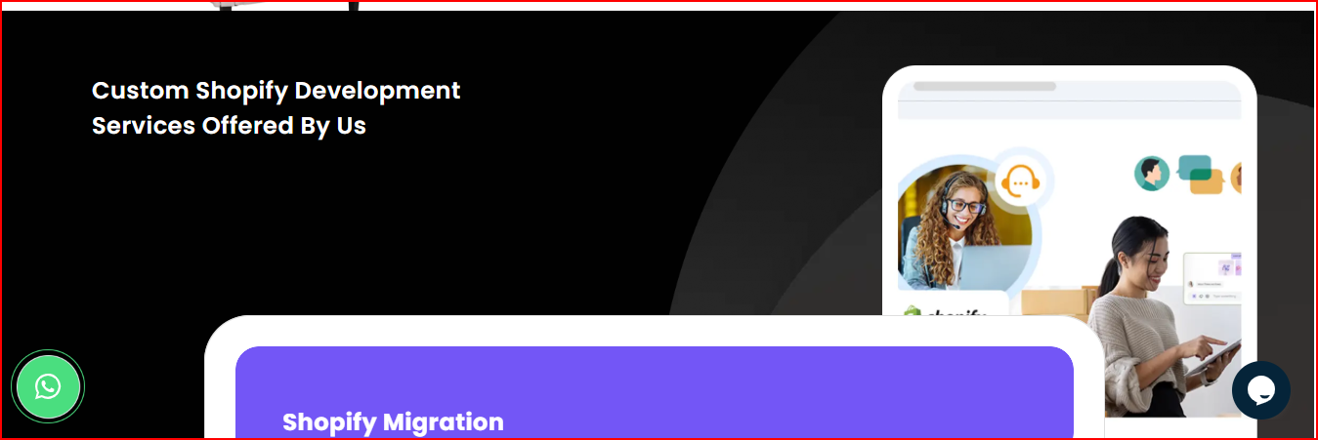

**Benefits of Custom Shopify Development for Your Business**

**1. Brand-Centric Design**  
Custom Shopify development ensures that your online store reflects your brand’s unique identity. Personalized designs and features enhance brand recall and foster customer trust, leading to better engagement and higher sales conversions for your e-commerce store.

**2. Optimized Performance**  
A custom-built Shopify store is optimized for speed, responsiveness, and search engines. With enhanced functionality and clean coding practices, your website loads faster, ranks higher in search results, and provides a seamless shopping experience across all devices.

**3. Scalable Architecture**  
As your business grows, so should your store. Custom development ensures your Shopify store is built to scale. From managing larger inventories to accommodating higher traffic volumes, we develop stores that evolve with your business needs effortlessly.

**Design Process of Shopify Website Development**

**1. Planning & Research**  
We start by understanding your business goals, target audience, and competitors. This initial research helps in creating a solid roadmap for your Shopify store, ensuring the development aligns with your long-term objectives.

**2. Wireframe Designing**  
Our team designs wireframes to visualize the layout and functionality of your store. This step ensures all elements are strategically placed for optimal user experience and conversion optimization.

**3. Development and Integration**  
We bring your store to life using the latest technologies and Shopify best practices. Features like payment gateways, third-party apps, and custom functionalities are integrated seamlessly during this phase.

**4. Quality Assurance**  
Each store goes through rigorous testing, including performance, functionality, and security checks. Our QA team ensures your Shopify store is error-free and ready for launch.

**5. Launch & Maintenance**  
After successful deployment, we provide ongoing support and maintenance. Regular updates, performance monitoring, and bug fixes keep your Shopify store running smoothly post-launch.

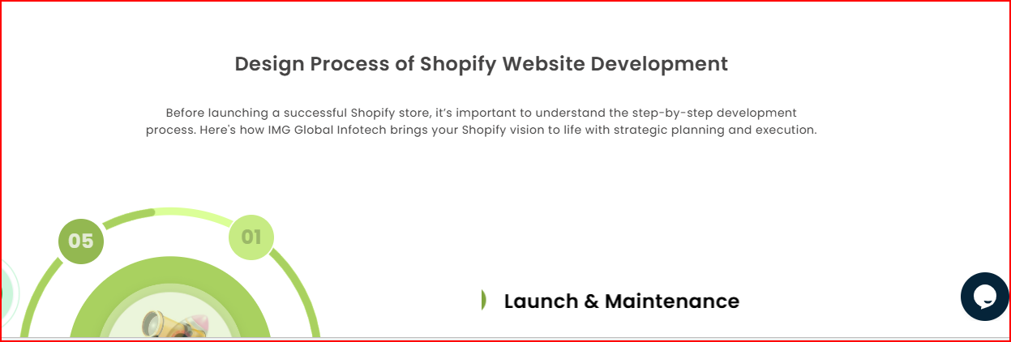

**Why Choose RS Organisation as Your Shopify Website Development Company?**

**1. Expert Shopify Developers**  
Our team consists of certified and experienced developers with in-depth knowledge of the Shopify ecosystem. We deliver feature-rich, high-performance Shopify stores that are customized to meet your business needs.

**2. End-to-End Solutions**  
From strategy and design to development and post-launch support, RS Organisation provides complete Shopify development services in Noida. We ensure your store is ready to compete and succeed in today’s fast-paced e-commerce landscape.

**3. Proven Track Record**  
With multiple successful projects delivered, RS Organisation has earned a reputation as a trusted **Shopify development agency in Noida**. We’ve helped clients across industries build and scale their e-commerce stores with measurable success.

**4. Transparent Communication & Support**  
We believe in building strong client relationships through transparent communication and reliable support. Our team keeps you updated at every stage of the project and is always available for any post-launch queries or enhancements.

